


Anguilla Maritime Administration
& Shipping Registry

AMASR

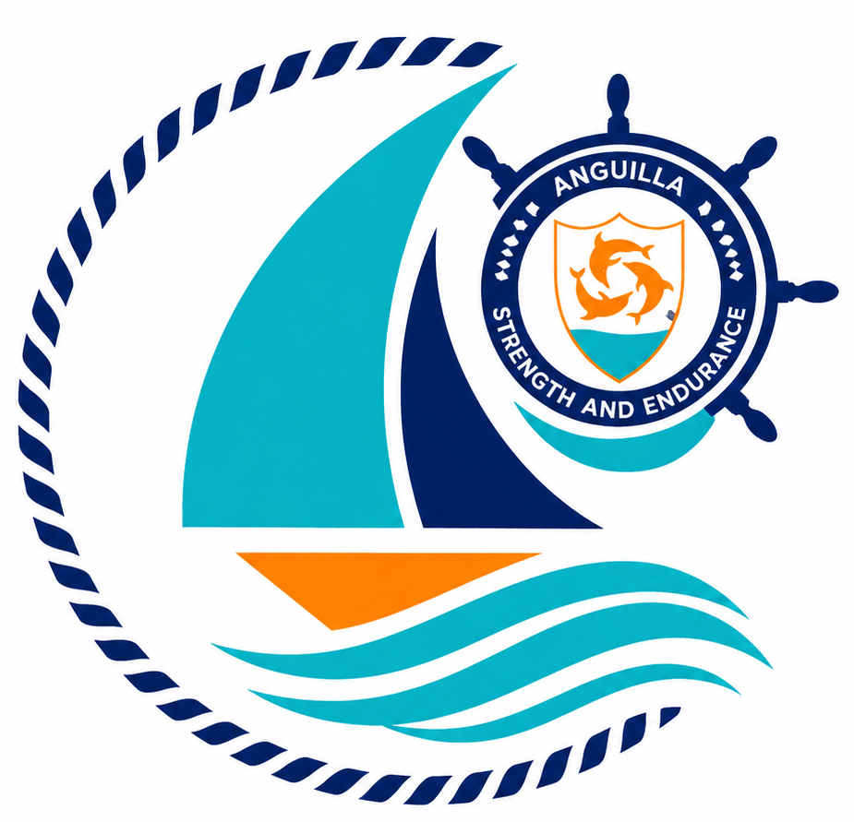

Form: | Application for Registration
No.: | 01
Rev.: | 00
Date: | 2026-06-10
To: | Recognized Organizations, Shipowners, Managers, Masters, Seafarers, Partners, Brokers, Surveyors, and the general public.

Strength and Endurance

Address: Anguilla Maritime Administration
Anguilla, Leeward Islands, Ministry of Infrastructure, Communications, Utilities and Housing, Coronation Avenue, The Valley Anguilla
Tel: +447454760022| Email: info@amasr.ai

FORM 01 - APPLICATION FOR APPLICATION FOR REGISTRATION
Please complete this form in its entirety, electronically or in block capitals.

1. Ownership details
a) If the vessel is owned by a company
Name of the owning company
Name of demise charterer (if applicable)
Registered address
Country of incorporation |  |  | VAT/registration n.
Contact person
Telephone n. |  |  | Email
IMO Number
b) If the vessel is owned by an individual
Name of the owner
Name of demise charterer (if applicable)
Permanent address
Nationality |  |  | Passport or ID n.
Telephone n. |  |  | Email
c) Correspondence address if applicable
Address
Telephone n. |  |  | Email
d) Management details (where applicable)
Name of ISM or technical manager
Registered address
Telephone n. |  |  | Email
Contact person |  |  | Role
IMO Number of ISM Manager
2. Vessel details
Vessel name
Previous Registration1 (if applicable)
Previous name (if applicable)
IMO number (if applicable)
HIN (if applicable)
Date of construction/Keel laid
Type of vessel
Gross Tonnage |  |  | Net Tonnage
Length overall LOA (m) |  |  | Length (Article 2(8))
Breadth (m) |  |  | Moulded depth (m)
Type of propulsion |  |  | Total propulsion (kW)
Builder name and address

1 If not applicable, specify if the vessel is a new build and has no previous registration. Please attach a copy of the BC (Builder’s Certificate) or a declaration of no prior registration by the registered owner.

3. Type of registration
Merchant vessel | Commercial yacht
Private yacht | Vessel under construction
4. Declaration concerning the Ultimate Beneficial Owner and sanctions compliance
I, the undersigned, hereby declare that as at today the ultimate beneficial ownership is not included in any list of individuals designated for the purpose of trade and/or financial sanctions and/or embargoes imposed by: (i) the laws of the European Union; and/or (ii) the Security Council of the United Nations, and/or OFAC and UK sanctions applied on a voluntary basis.
If the registered owner is a legal entity, I also declare that both the ship owner and the ultimate beneficial owner (UBO) are not included in any list of individuals or entities designated for the purpose of trade and/or financial sanctions and/or embargoes imposed by: (i) the laws of the European Union; and/or (ii) the Security Council of the United Nations, and/or OFAC and UK sanctions applied on a voluntary basis.
If the applicant ship owner is a legal entity, I also declare that the ultimate beneficial owner (UBO) of the ship owner is the following individual (indicate one or more individuals):
5. Declaration²
I, the undersigned, declare under my own responsibility that I have not made any false or misleading statements in this form, being aware that anyone who makes false or misleading statements is punishable under the Criminal Code of the Anguilla.
I, the undersigned, further declare and confirm that all fees relating to the present registration application, as well as any current charges, have been duly paid in accordance with the applicable fee schedule of the Maritime Registry of the Anguilla.
I, the undersigned, further acknowledge and accept that any fee and/or charge paid at the time of submission of the vessel registration application is generally non-refundable, regardless of the outcome of the procedure, except in specific cases subject to the exclusive and unquestionable discretion of the Administration.
Signatory full name in block letters | Role
Date | Signature

Note: Refer also to the guidance notes overleaf.

2 Power of attorney (or suitable corporate document) to be attached where applicable.

- This application must be signed:

  - by the owner of the vessel, if they are a natural person.
  - by a company director or authorized representative with power of attorney, if the owner is a legal entity.

- A foreign individual or foreign company will be eligible for registration of a vessel in San Marino after appointing a representative who is resident or legally registered in San Marino, who will be responsible for communications with the SM MNA (form 2).
- If the vessel is owned by multiple individuals or companies, all names and addresses of the co- owners shall be attached to this form on a separate sheet (indicating the respective ownership shares).
- The address provided in points 1 a) or b) will be used in the Certificate of Registry COR. The correspondence address indicated, if different, will be used only for safety-related communications.
- If the registered owner of the vessel is a company, the application must be accompanied by:

  - an updated list of all directors issued by a competent authority or bearing a notary's stamp.
  - a list of all company shareholders, issued by a competent authority or bearing a notary's stamp, and their passports or identity cards.
  - Documentary evidence on the UBO(s) if not included in the list of company shareholders.

- If the registered owner of the vessel is an individual, the application must be accompanied by:

  - a copy of their valid passport or identity card.

- If the application is signed by a third party, a power of attorney is required specifying the precise delegated activity, the vessel in question, and the name of the delegate.
- The UBO (ultimate beneficial owner) declaration must be accompanied by the following documents:

  - copy of the passport (or identity card) of the ultimate beneficial owner of the legal entity owning the vessel.
  - documentary evidence establishing UBO status (if not already included in the shareholders list).
  - if the shareholder is a bank, it is sufficient to provide documentation of the board of directors' composition;
  - if the shareholder is a public administration or publicly traded company, verification of the final UBO is not necessary as these are already regulated entities; therefore, it will be sufficient to provide a certificate/extract attesting to such status (including public extracts).

- All documents must be in Italian or English. Documents in other languages must be accompanied by an official translation made by an authorized translator with stamp.

